Capstone Project

Name: Rohan Paul

Wipro DevOps Training Batch-1

Email_ID: rohanpaul2012@gmail.com

Project Name: Book My Show DevOps LifeCycle

Questions –

Step 1: Jira Workflow
• Each candidate must assign themselves tasks in Jira.
• Track task progress using Jira board (To Do → In Progress → Done).
• Export the board as part of the final submission.

Step 2: GitHub Workflow
• Clone the GitHub repository: https://github.com/akshu20791/Book-My-Show/
• Create a feature branch and make changes.
• Push changes and raise a Pull Request (PR).
• Review peers' PRs and approve before merging into the main branch.
• Submit the final PR link as deliverable.

Step 3: Jenkins CI/CD Pipeline
Pipeline stages to implement:
1. Clean Workspace
2. Checkout Code from GitHub
3. SonarQube Analysis (Quality Gate)
4. Install Dependencies (NPM)
5. Trivy FS Scan (Optional)
6. OWASP Dependency Check (Optional)
7. Docker Build & Push to DockerHub (via Jenkins)
8. Deploy to Docker Container
9. (Optional) Deploy to Kubernetes (EKS)
10. Email Notification on build result
Note: Candidates must implement this pipeline using a Jenkinsfile and submit the Jenkinsfile
as a deliverable.

Step 4: Docker Deployment
• Candidates must write their own Dockerfile to build the BMS app image.
• Build Docker image and push to DockerHub via Jenkins.
• Run container locally and validate accessibility on port 3000.

Step 5: Kubernetes Deployment (EKS)
• Candidates must write their own Kubernetes manifests (deployment.yaml, service.yaml).
• Deploy the application on EKS cluster.
• Expose service using NodePort or LoadBalancer.
• Validate deployment using 'kubectl get pods' and 'kubectl get svc'.

Step 6: Monitoring & Observability
• Install Prometheus and Node Exporter to collect metrics.
• Integrate Jenkins metrics into Prometheus.
• Install Grafana, configure Prometheus as a data source.
• Add dashboards for Node health and Jenkins performance.
• Submit Grafana screenshots in deliverables.

Final Deliverables
1. Jira Board Export (task progress).
2. GitHub PR link.
3. Jenkins pipeline execution logs.
4. Jenkinsfile (mandatory).
5. SonarQube Quality Gate report.
6. (Optional) Trivy/OWASP reports.
7. DockerHub repository link.
8. Dockerfile (mandatory).
9. EKS deployment proof (kubectl outputs).
10. Kubernetes manifest files – deployment.yaml and service.yaml (mandatory).
11. Prometheus & Grafana screenshots.
12. Email notification screenshot.
13. Final summary report (Word/PPT)

GitHub Fork Repository Link:

https://github.com/RohanPaul10/Book-My-Show_capstone_project.git

Jira Board Export (task progress)
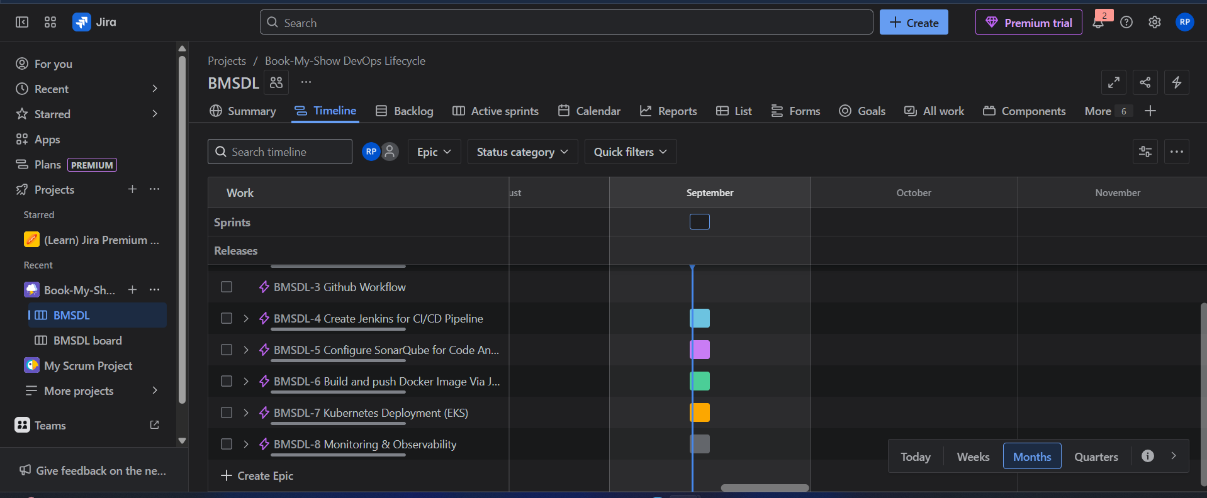
Assign Epics in Jira DashBoard (Epic1.Jira workflow setup, E2.GitHub Workflow,E3.create jenkins for ci/cd for ci/cd pipeline, E4.Configure SonarQube for code analysis,E5. Build and push Docker Image Via Jenkins Pipeline,Kubernetes Deployment(EKS),E6.Monitoring & Observability)

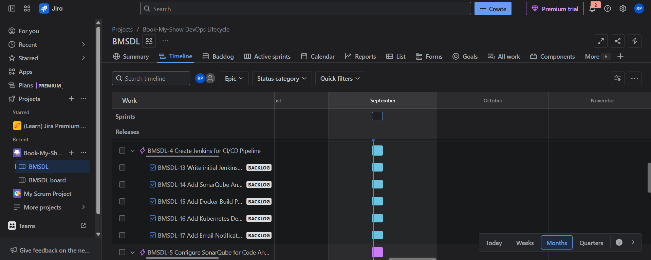
Adding Some Subtask Under Epics

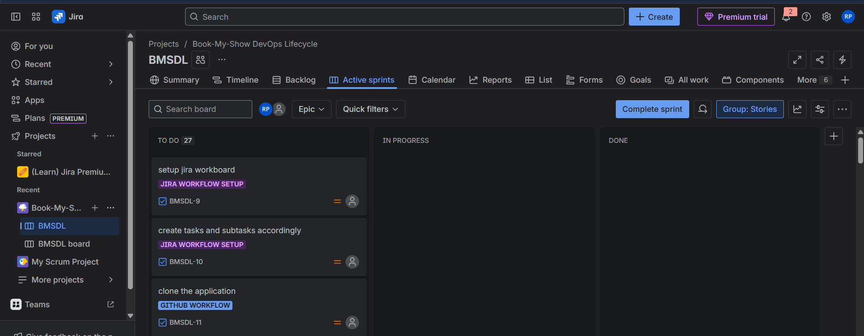
Create one sprint Track task progress using Jira board (To Do → In Progress → Done)

Working on the task and aiming to complete the sprint

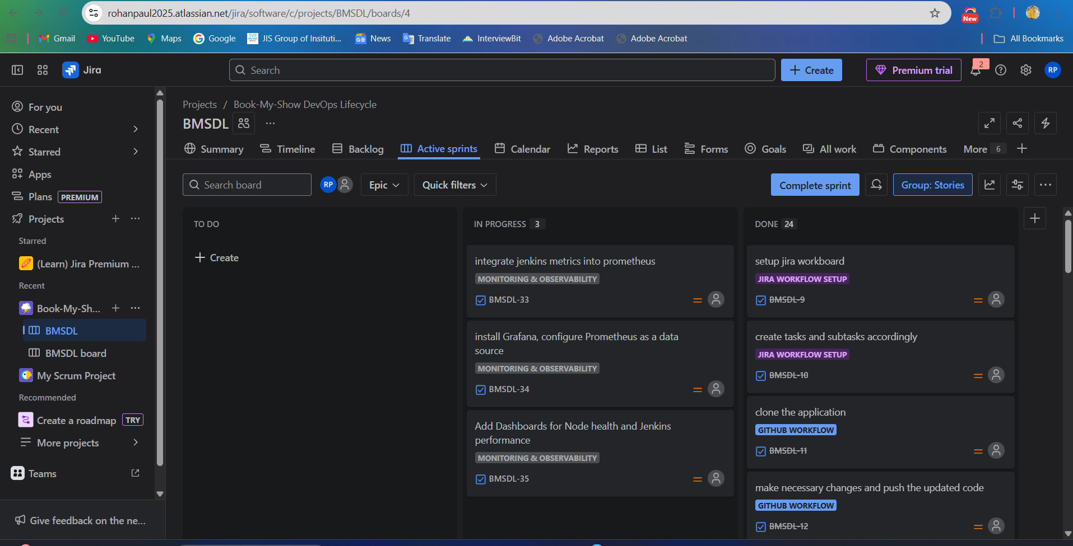

Successfully completed the sprint and finished all tasks

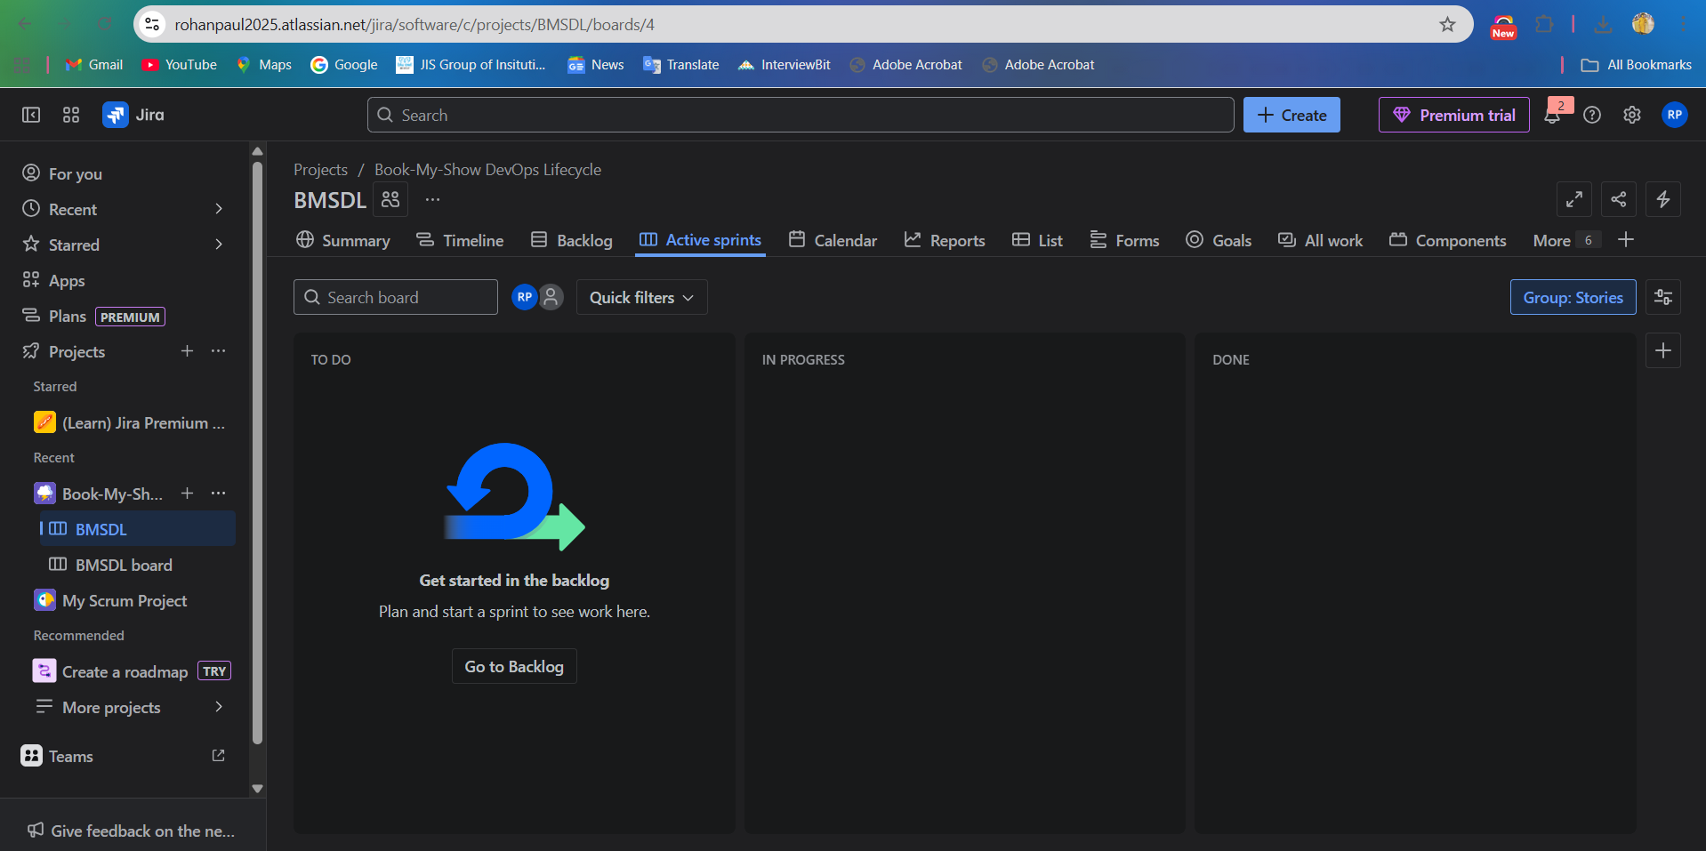

GitHub PR link

Fork and clone the GitHub repository, create a feature branch, implement changes, and push them

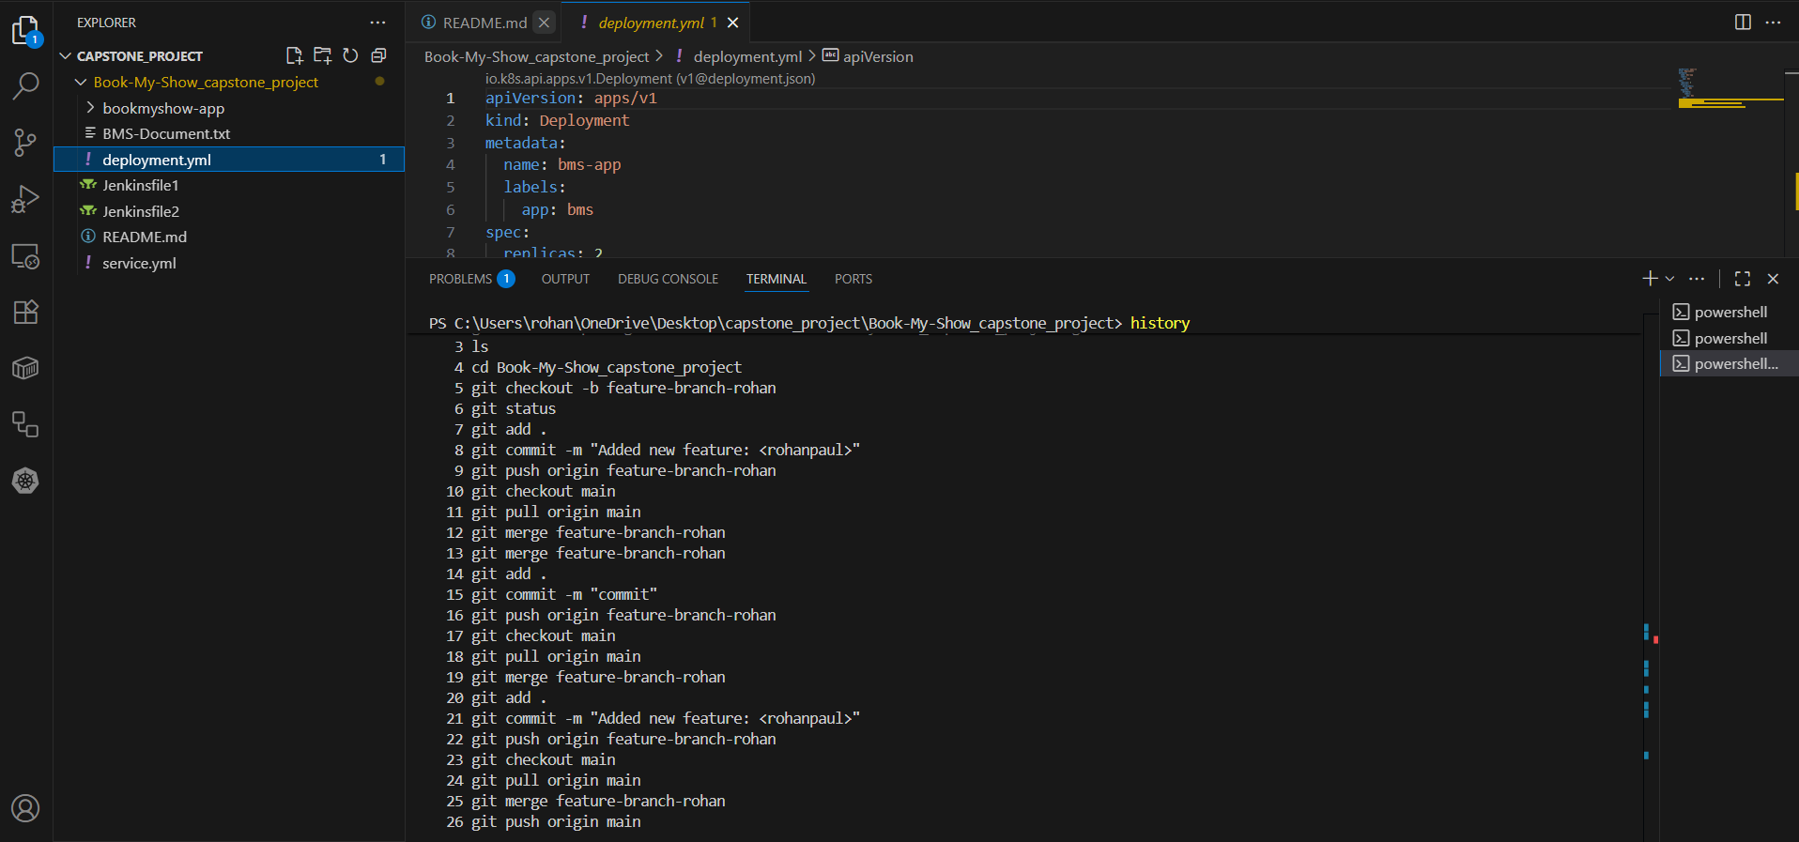

Review peers' PRs and approve before merging into the main branch
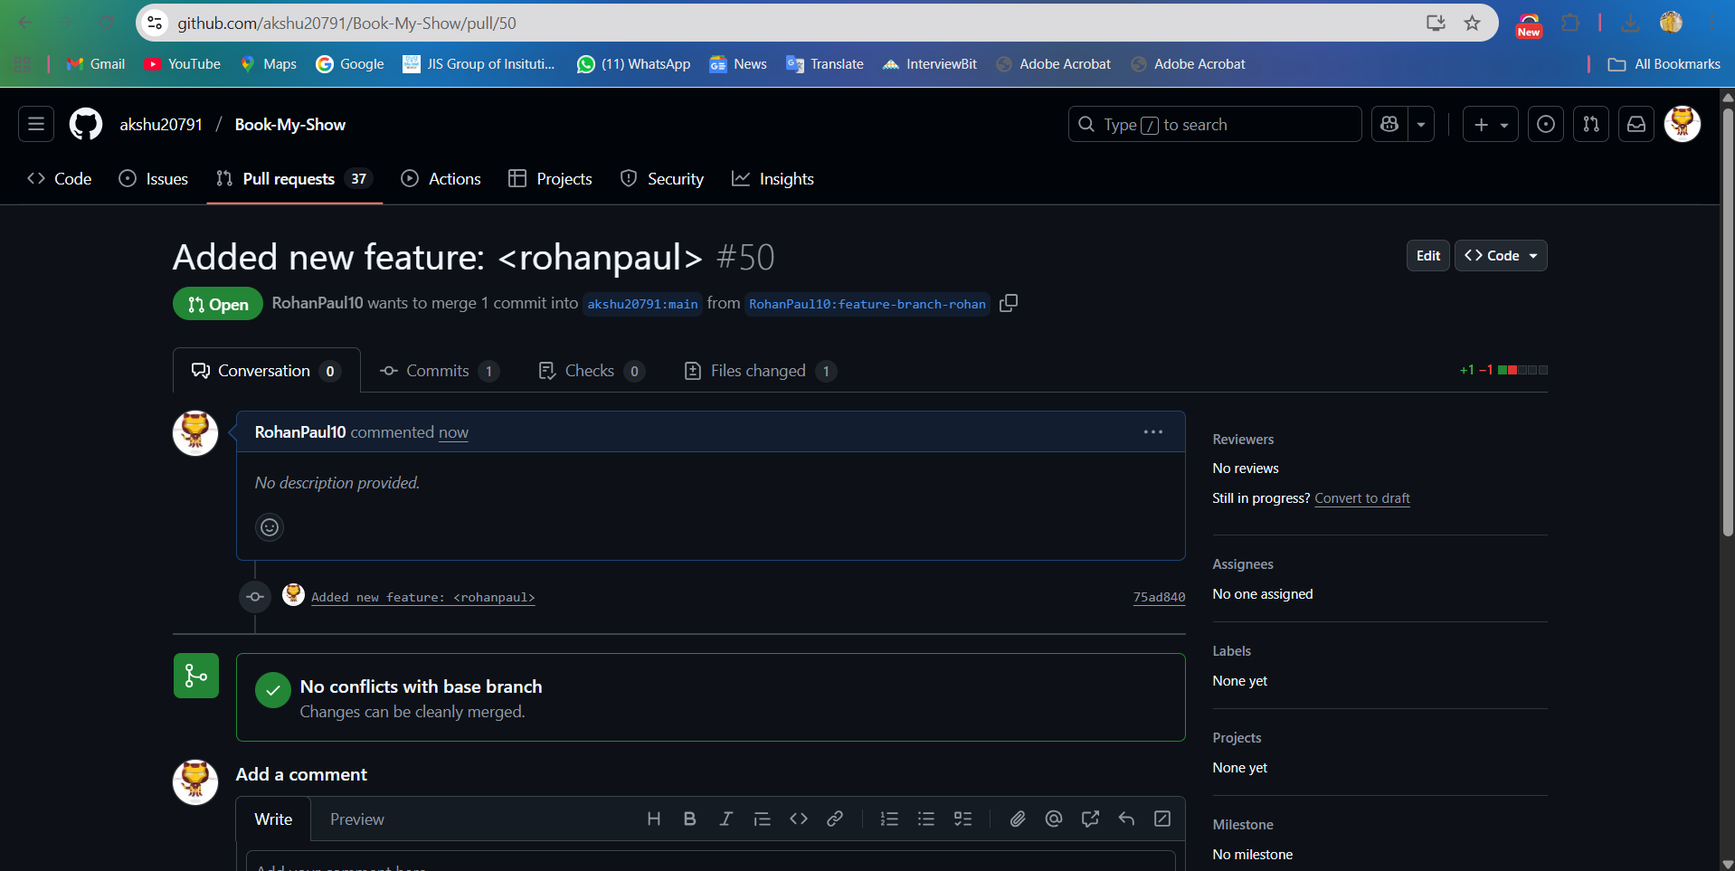

Raise a Pull Request (PR)

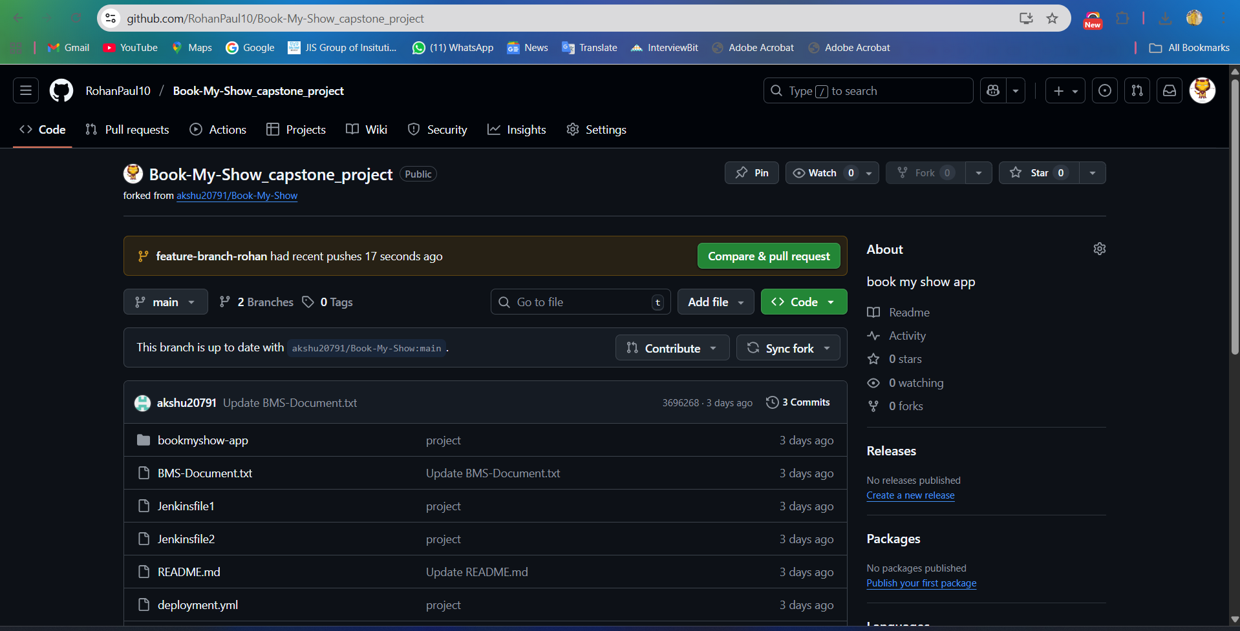

GitHub PR Link :

https://github.com/akshu20791/Book-My-Show/pull/50

Jenkins Pipeline Execution Logs
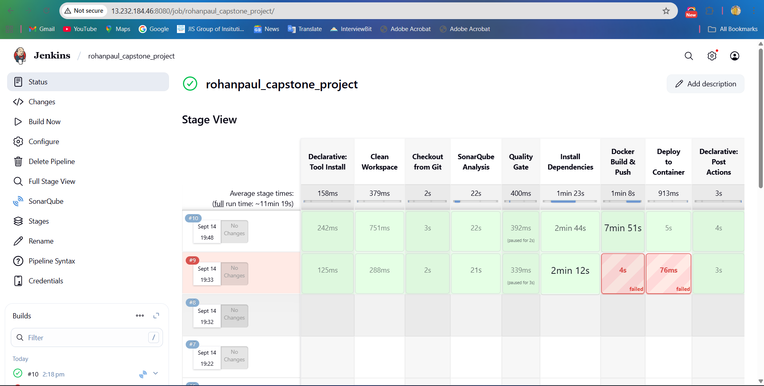

SonarQube Quality Gate Report
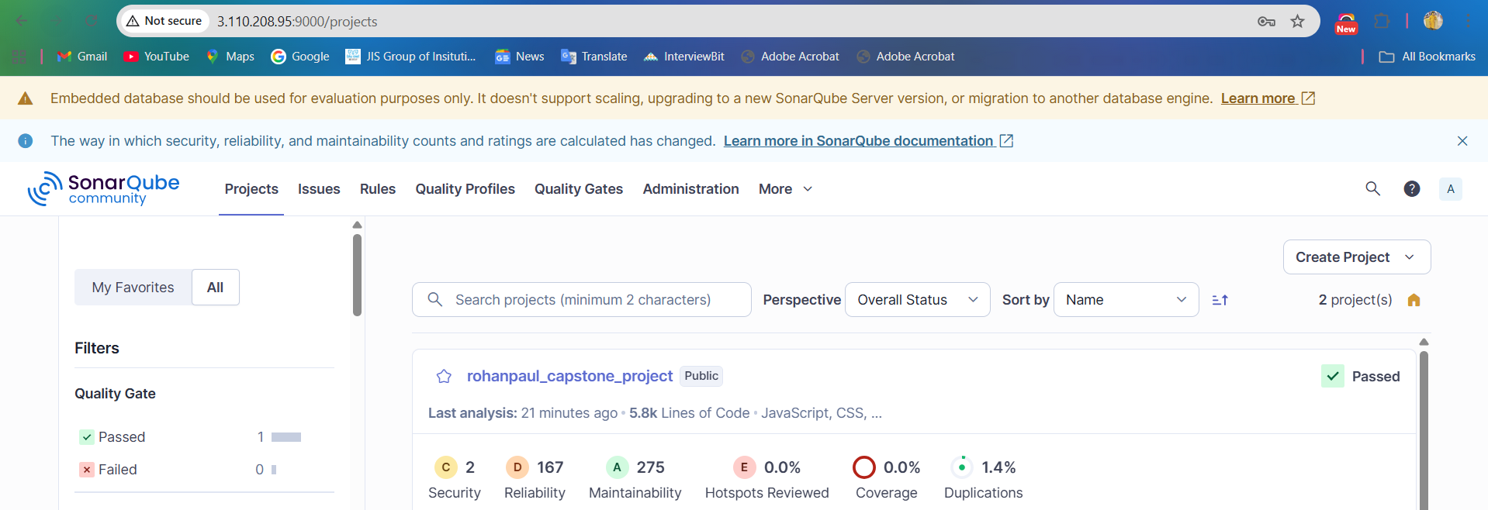

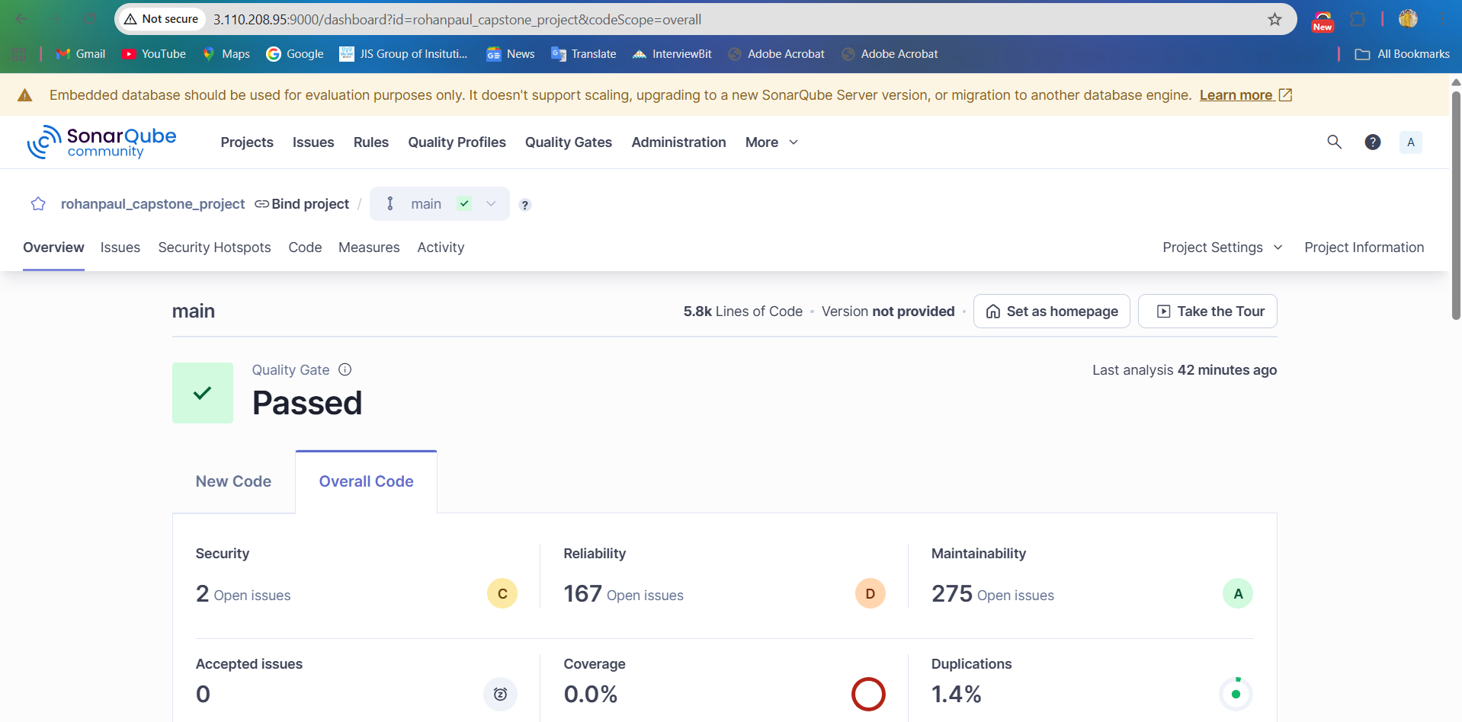

A SonarQube Quality Gate is like a checklist of conditions that code must pass before it can be considered ready for release.
It’s a set of rules/thresholds that ensures your code meets defined quality standards.
For example, it can check things like:
- No new critical or blocker bugs/vulnerabilities.
- Code coverage on new code is above a certain percentage (e.g., 80%).
- Duplicated code is below a threshold.
- Maintainability issues are within limits.
If the project fails the Quality Gate, it means the code does not meet the required standards and should not move to production.

Dockerhub Repository
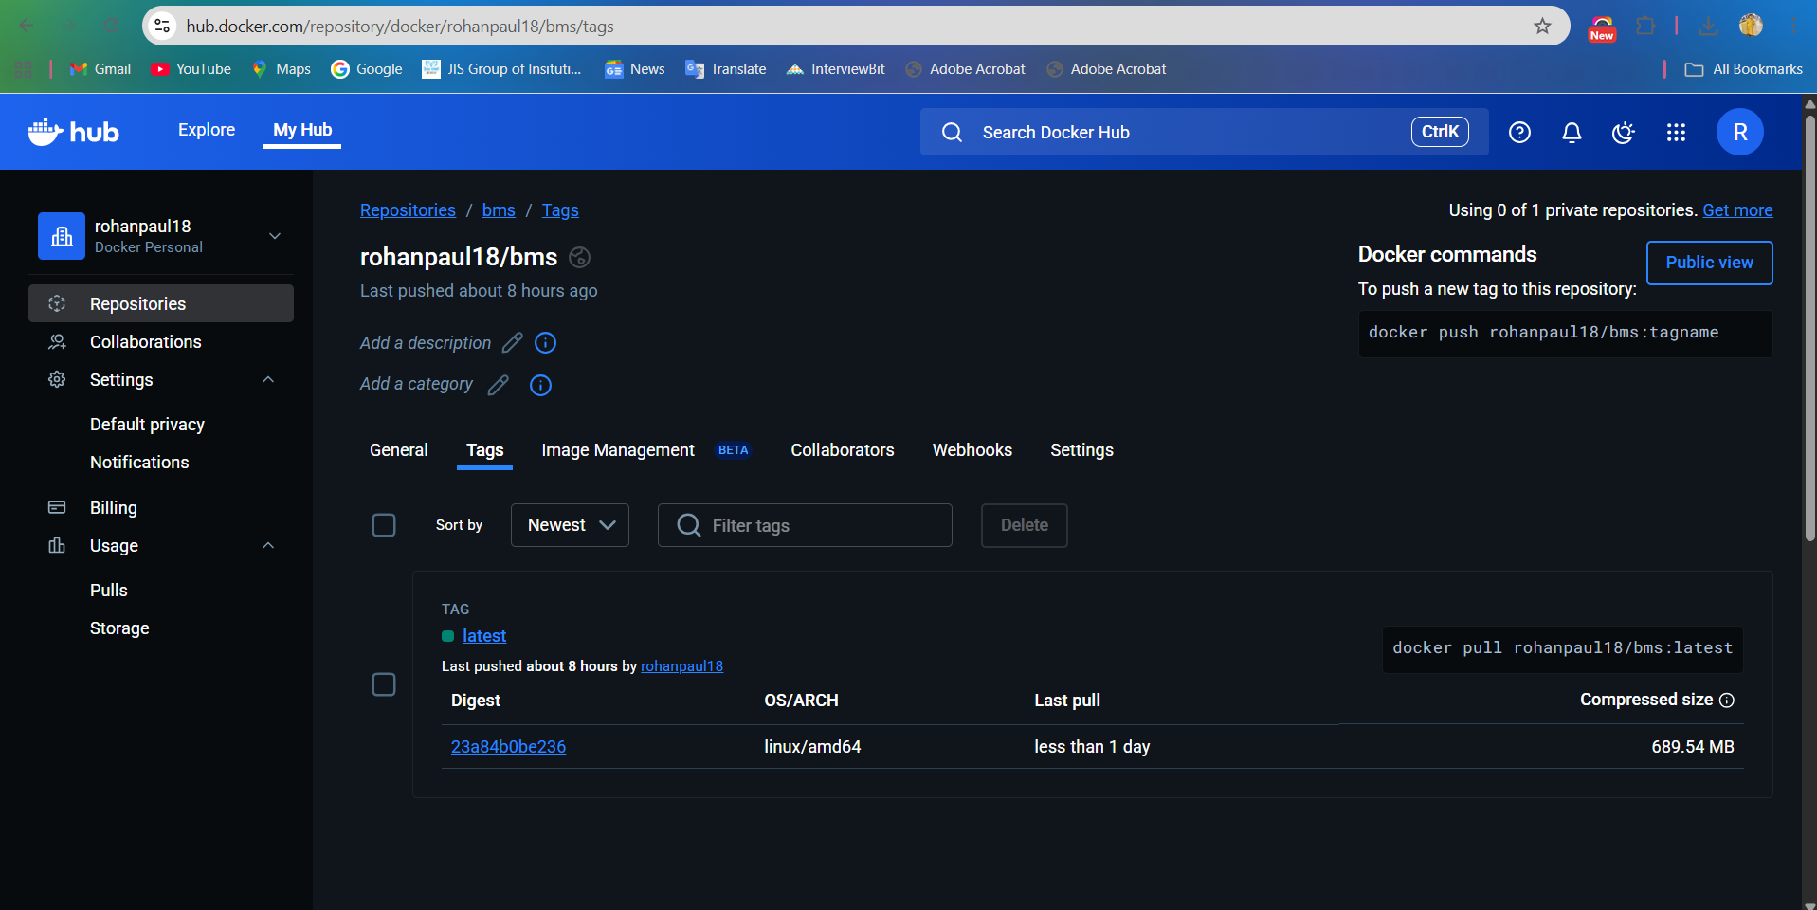

Docker Repo Link:

https://hub.docker.com/repository/docker/rohanpaul18/bms/tags

EKS deployment proof (kubectl outputs)
Validate deployment using 'kubectl get pods' and 'kubectl get svc'
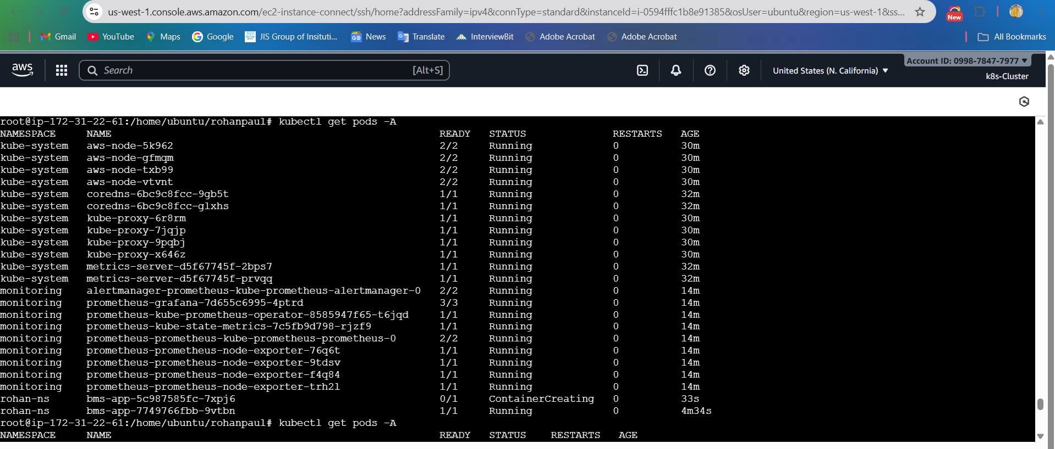

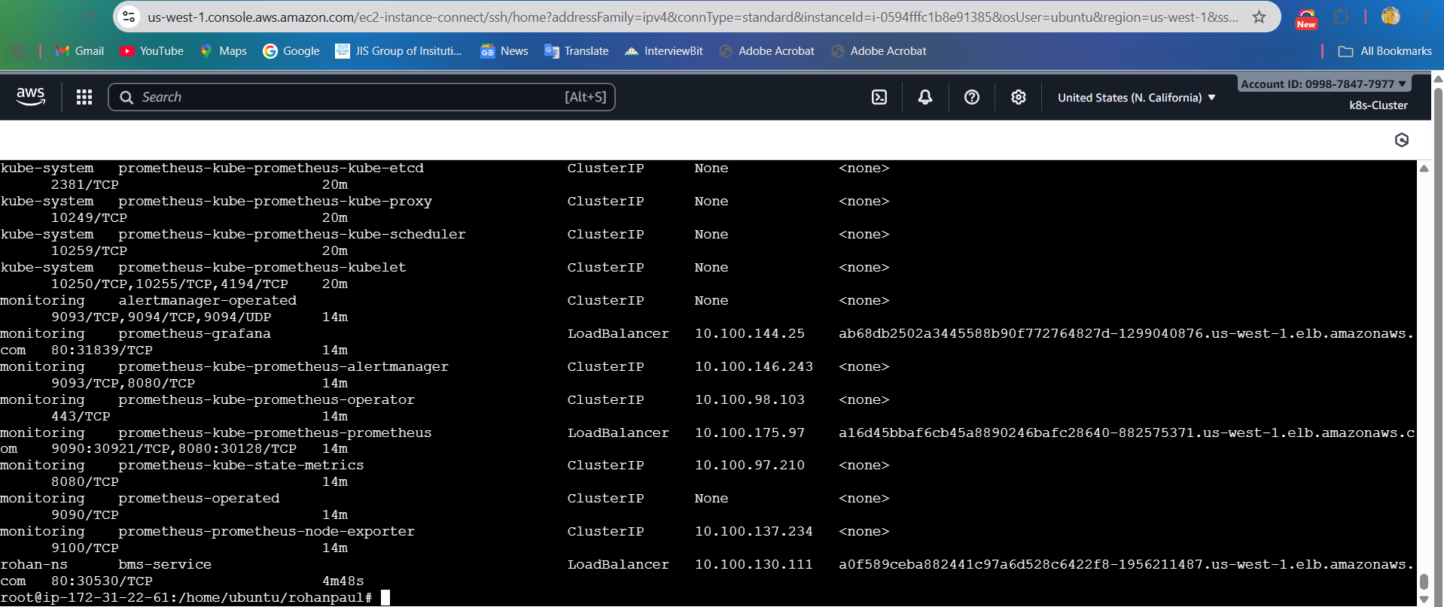

Configure The Book My Show Application


Prometheus & Grafana screenshots

In prometheus checking the target health status
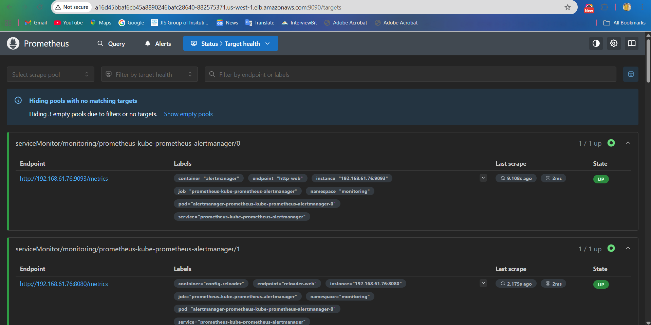

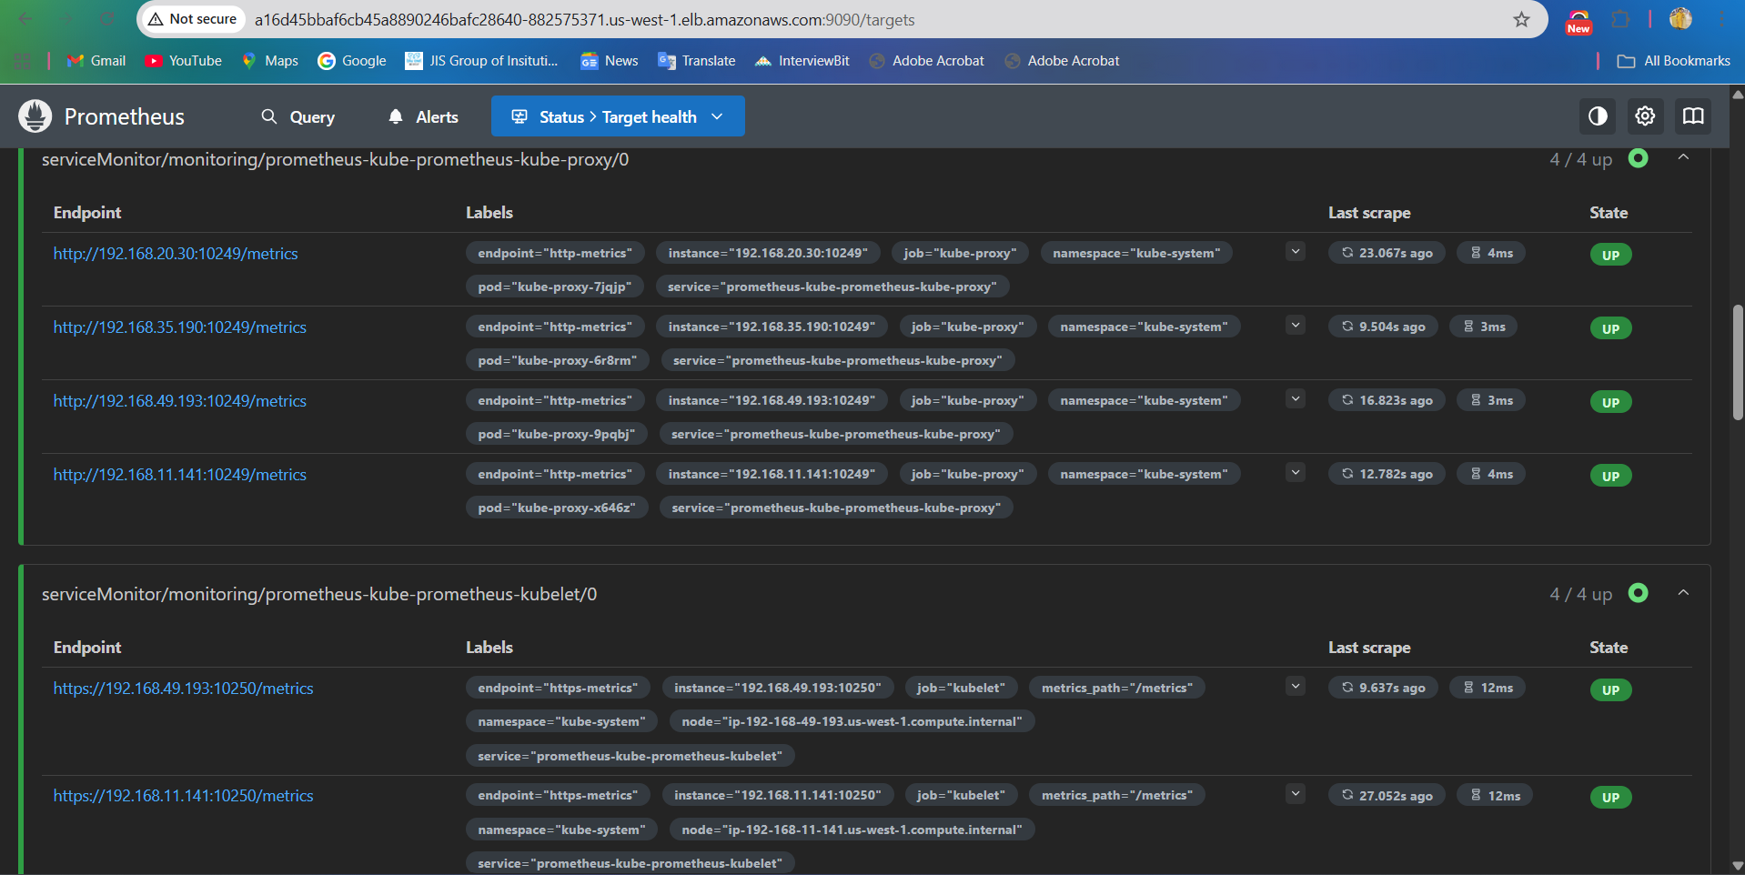

Creating a Grafana Dashboard to Check Node health and Jenkins performance
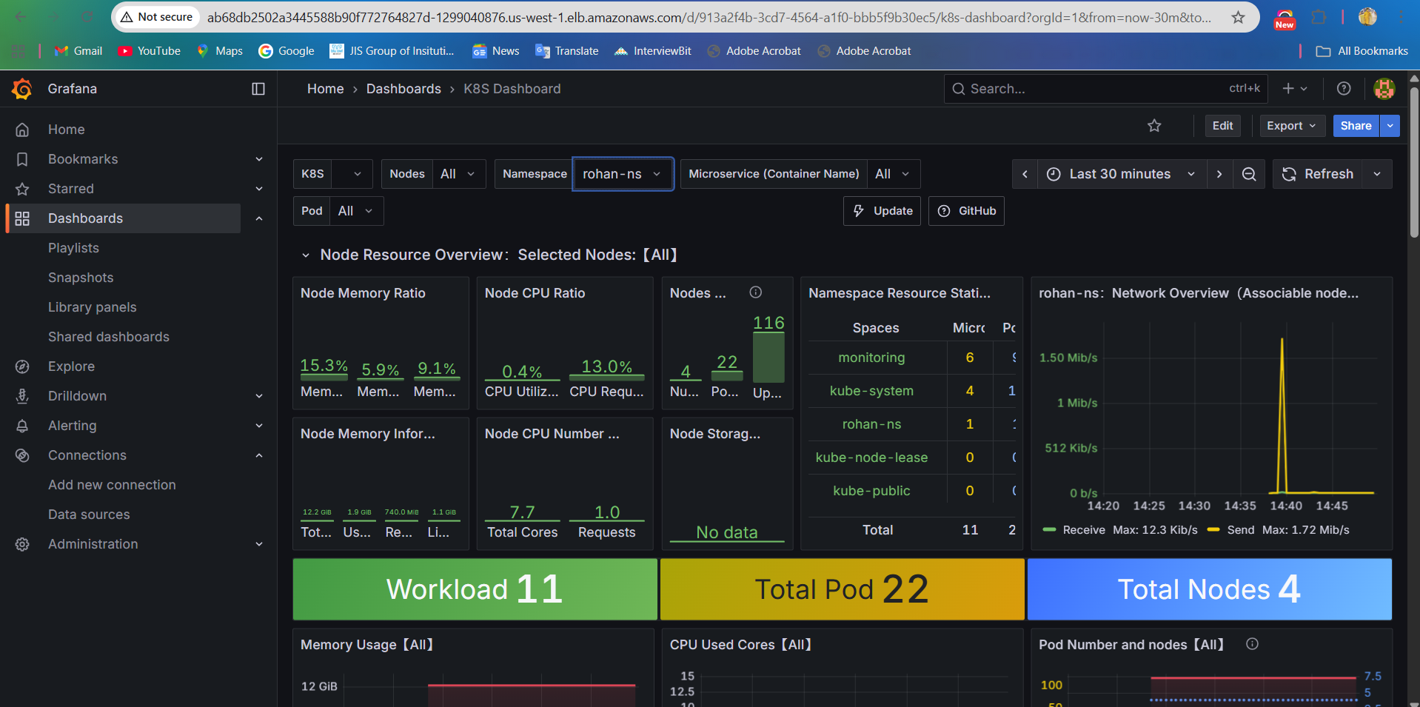

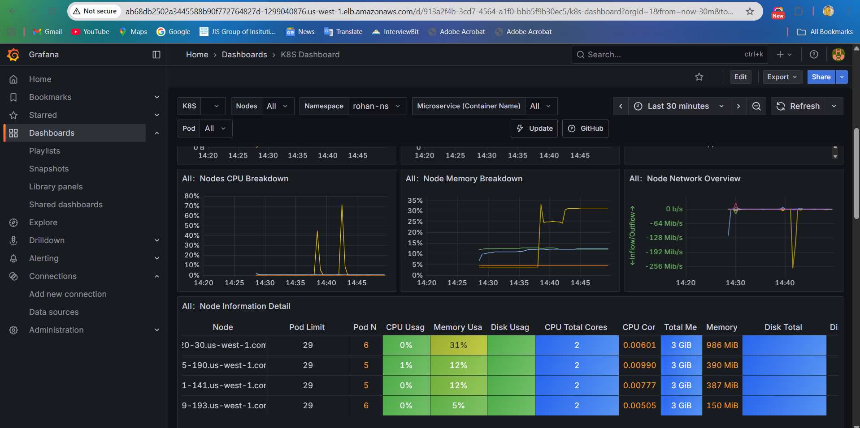

Email Notification Screenshot
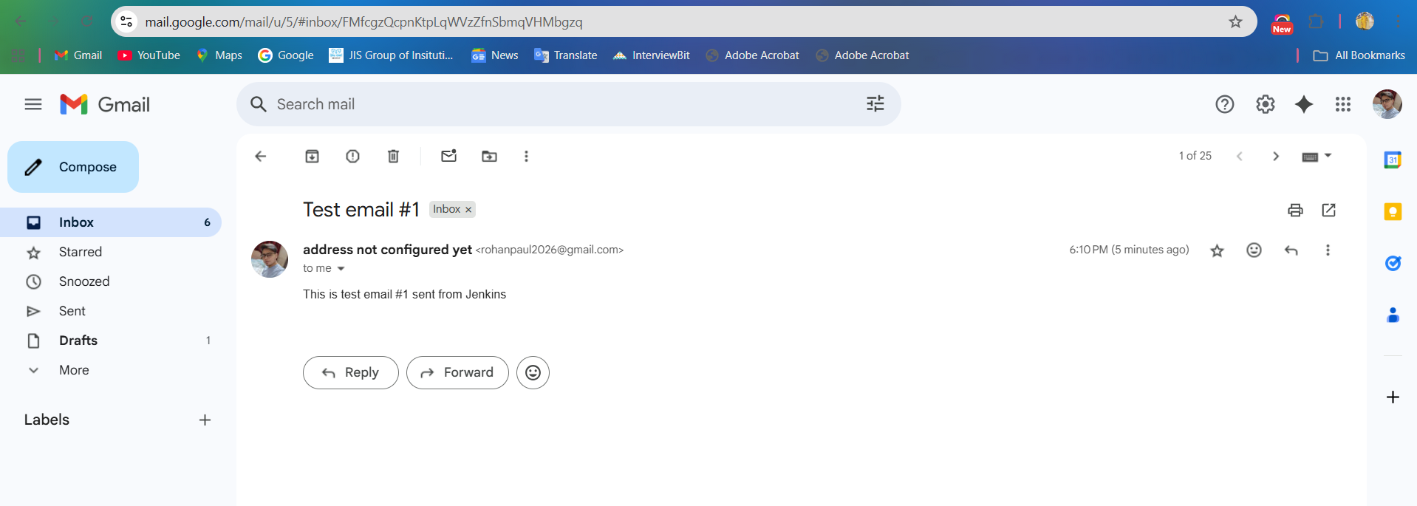

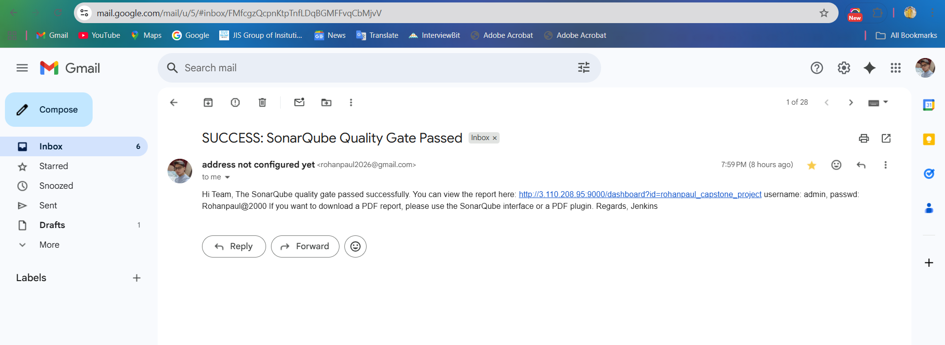
SonarQube Quality Gate Passed:

